**Project Design Phase-II**

**Data Flow Diagram & User Stories**

| Date | 03 October 2022 |
| --- | --- |
| Team ID | PNT2022TMID03817 |
| Project Name | Smart solutions for railways |
| Maximum Marks | 4 Marks |

**Data Flow Diagrams:**

A Data Flow Diagram (DFD) is a traditional visual representation of the information flows within a system. A neat and clear DFD can depict the right amount of the system requirement graphically. It shows how data enters and leaves the system, what changes the information, and where data is stored.

**Example:** [**(Simplified)**](https://developer.ibm.com/patterns/visualize-unstructured-text/)

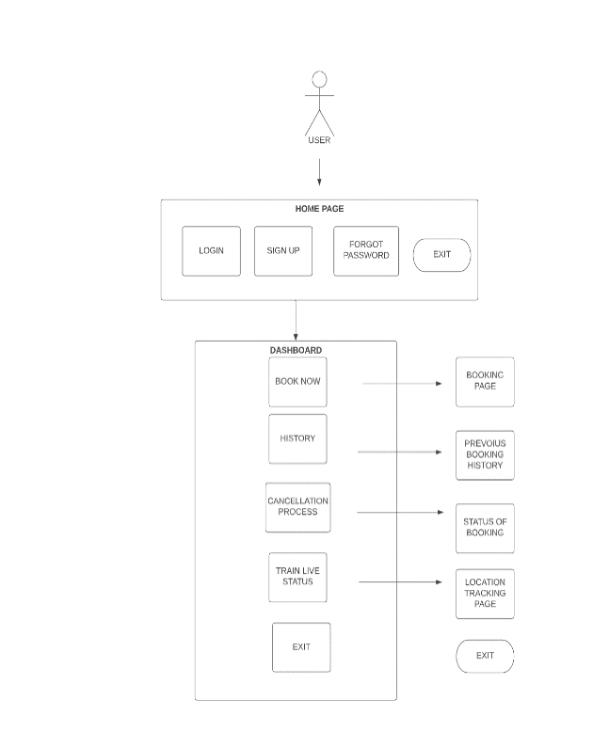

**User Stories**

Use the below template to list all the user stories for the product.

| **User Type** | **Functional Requirement (Epic)** | **User Story / Task** | **Acceptance criteria** | **Priority** | **Release** |
| --- | --- | --- | --- | --- | --- |
| Customer (Mobile user) | HOME PAGE | As a user can used the website to logi and sign up and user can change the password by using forgat password page in the home page | I can used to login | High | Sprint-1 |
|  | Dashboard | In this dashboard it consist all the registeration process and cancellation process | I can access my account / dashboard | High | Sprint-1 |
|  | Redirecting page | In this redirecting page it consist the current information of registration and train location and cancellation process | In this page it will used to get information about the registration and cancellation | High | Sprint-1 |